Library System

By: Sean Wilson



A more modern way to manage your library!

Demo Link:

<http://library.purplefirehosting.com/>

GitHub Link:

<https://github.com/seanwil12/LibrarySystem>

Features

Search Feature

Users can easily search for their book by entering text in the search box and pressing search. It’s that easy! 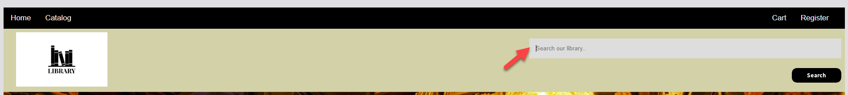

Login Feature

Library Catalog

Utilize our online catalog to see which books are in your inventory and allow quick check out.